Lecture #8
How to develop and maintain Information System.
Firms organize their Information Services function in very different ways, reflecting the nature of their business, their general structure and business strategy, their history, and the way they wish to provide information services to the business units. Most of the IS departments remain centralized.

Planning:
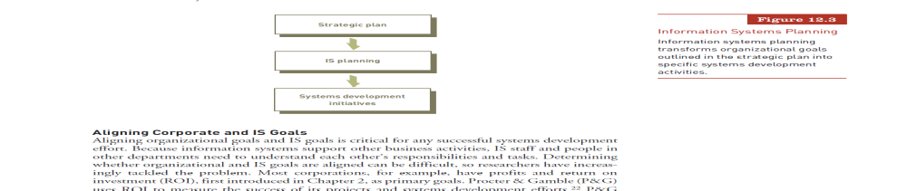
The first step involves preliminary planning, which includes obtaining a full understanding of the gaps the business is looking to fill, evaluation of alternative solutions and the development of a preliminary budget and timeline to allocate resources if and when needed. The planning stage helps the business make its final decision and prepares the company for the upcoming project.

Analysis:
This step analyzes the plan and begins to create a list of specifications and requirements the system will have to meet. Here functions are spelled out, communication protocols are established and a picture can be built of the end product. Often, work moves back and forth between the analysis and planning stages, when the potential system requirements hit a wall with regards to budget or schedule, so that the final picture can be agreed on by everyone.
Design:
This is the actual development stage. The team will come together and begin to build the code, databases and functions that will power the IS as needed and required by the previous stages. This stage also includes extensive testing, first by the development team and then by the real users, to determine whether things are working as expected.
Implementation:
This stage begins with formal testing and troubleshooting of the entire system before the new IS goes live. Once the system has been accepted, integration into the existing day-to-day workload begins. In larger, more extensive systems, deployment may happen by module or by department; for smaller systems, implementation can go live all at once.

Maintenance:
The final stage involves monitoring the system to keep it current and functional. Users will report bugs or problems with the system, which the customer service support team will need to address. This stage should include extensive documentation for future users. It also often includes an evaluation of the workplace before and after, to ensure the system is meeting expectations; ongoing evaluations and new development are necessary to ensure the system does not become obsolete.

